How does SomnoDent work?
Somnodent is a Mandibular Advancement Splint, sometimes called a mouthguard or oral appliance. Your custom-made device will fit comfortably over your teeth. It works by moving your lower jaw slightly forward. This forward movement helps to keep your airway continuously open.
SomnoMed patients’ feedback:
- 91% are sleeping better at night.¹
- 88% use their device regularly¹
- Almost 100% of those who use it, continue to use their device for long-term treatment of their condition.

Convenient

Almost 9 out of 10 Australian SomnoDent users report that their device is comfortable to wear and report better sleep.
While wearing a SomnoDent device, you’ll be able to fully open and close your mouth, yawn, drink, take tablets and even speak clearly. You won’t feel restricted or claustrophobic. You won’t have to remove it to go to the bathroom in the night.
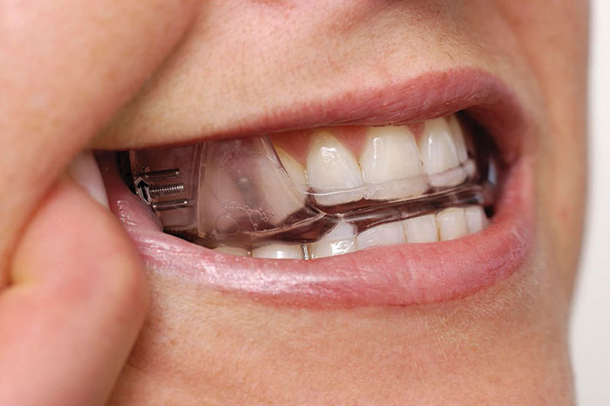

Effective

15 independent studies demonstrate Somno-Dent’s significant benefits in the treatment of mild to moderate OSA. It’s the oral device most widely prescribed by Australian sleep physicians.₂
SomnoDent devices have already been used by over 40,000 Australians and 300,000 people worldwide.₂

Comfortable

A SomnoDent device is simple to use and care for. It makes the perfect travel companion, being easily portable for use during air travel and on holidays. Unlike CPAP, you don’t need access to a power outlet. You can easily fit it in your hand luggage.

